



**SAFETY IN STUDENT PLACEMENT POLICY AND GUIDANCE**

|  |  |
| --- | --- |
| Policy Number | SS-GU-048 |
| Version Number | 1 |
| Publishing Availability | University-wide |
| Approval Date | Nov 2023 |
| Approved By | Health and Safety Management Group |
| Review Date | Nov 2027 |
| Lead Responsibility | Director of Education and Student Services |
| Lead Author | Trevor Johnston, Education and Student Services  Julie McConkey, University Safety Service |
| Cross Reference to Compliance Review | HSR18 |

**Overview**

This document is maintained electronically and the latest issue accessible via the Safety Service website. Printed copies shall be treated as uncontrolled documents.

Comments or queries relating to the contents of this document should be referred to:

Head of University Safety, University Safety Service, e-mail: [safety@qub.ac.uk](mailto:safety@qub.ac.uk)

Reviewed by the University Safety Service

Nov 2023

**Contents**

1. **Section A – Policy**
   1. Policy Rationale 4
   2. Policy Statement 4
   3. Policy Objectives 5
   4. Legislation 5
   5. Scope 6
   6. Definitions 7
   7. Responsibilities 7
   8. Communication, co-ordination, and co-operation 9
   9. Consultation 9
   10. Implementation and Monitoring 9
   11. Approval and Review 9
   12. Communication and Further Advice 10
   13. References 10
   14. Document Change Log 10
2. **Section B - Guidance**

2.1 Planning and organisational arrangements 11

2.2 Review and Approval of Placements 12

* 1. Roles and Responsibilities 15
  2. Preparing Students 16

2.5 Processes for Monitoring Contact and Resolving Problems 17

* 1. Planning for Contingencies 17

2.7 Incident Reporting 18

2.8 Annual Review 18

**Appendices:**

Appendix 1: Consultation ………………………………………...………………………………. 19

Appendix 2: Work Placement Opportunity Form and Placement Details 20

Appendix 3: Student Placement Form of Indemnity 22

Appendix 4: Work Placement Health and Safety Checklist 25

Appendix 5: Suggested Questions for Placement Monitoring 27

Appendix 6: Risk Profiling and Risk Reducing Actions 28

Appendix 7: Risk Profiling Examples from Schools 34

1. Section A - Policy

1.1 Policy Rationale

This document is based on the Universities’ Safety and Health Association (USHA) Guidance on Health and Safety of Placements for Higher Education Students 2018 which was drawn up to provide guidance to the University sector on the management of student placements.

This Policy and Guidance provides a strategic and generic framework for the management of the health, safety and welfare of students on placement and the risks arising from health and safety related liabilities associated with placements.

This guidance describes what is required in approving placements, preparing students for placement and supporting the students in terms of their health and safety on placement both in the UK and overseas, and encourages a risk-based approach. It applies to Undergraduate and Masters’ level students undertaking placements.

This guidance provides a risk-based approach that can be applied to manage the diversity of placements. This allows a lighter touch on placements with relatively low risks and mor rigorous control measures where the risks are greater.

Placements with established Service Level Agreements (SLAs) in place which already include arrangements for health and safety (such as medical and nursing students on placement with local Trusts) are excluded from this policy.

1.2 Policy Statement

The University is committed to ensuring, as far as is reasonably practicable, the safety of students who are undertaking placements. The aim is to protect students from injury or illness, and to meet the requirements of the legislation and UCEA/USHA guidance, by assessing the risks associated with placements and reducing the risk of injury to the lowest reasonably practicable level. This will be achieved by ensuring that management procedures for authorising placements are in place, students are prepared prior to taking up their placements, and are monitored during their placements.

The University reserves the right to refuse to approve or halt a placement that is not being effectively managed, including on health and safety grounds. The University’s guidance has been designed to reflect the generic framework presented by national sector guidance.

1.3 Policy Objectives

It is important to recognise that the statutory liability for the health and safety of a student on placement primarily lies with the Placement Provider. The University is required to do what is reasonably practicable to ensure that students are placed in a working environment where there is suitable management of any placement associated risks. Schools are expected to document how student placements will be managed, including clearly defined roles, responsibilities and approval procedures. This should include a mechanism for escalation of approval where necessary and should preferably be part of the overall academic guidance or regulations on student placement. Management of student placement will be subject to audit during Health and Safety audits.

This guidance sets out a framework which will allow the University to fulfil its duties to students under health and safety legislation. It will also enable students to be sufficiently informed whilst on placement of health and safety matters.

It is recommended that Schools adopt the following risk management principles to the management of student placements:

* Clarity of understanding by each party of their roles and responsibilities.
* Preparation of the student such that they are in a position to understand the risks and to make informed judgements.
* There are processes for enabling problems to be raised and resolved prior to, during the course of, and at the conclusion of placement.
* There are contingency plans in case there are special circumstances, such as a student needing to withdraw from or change their placement.
* Staff who are involved in handling student placements have sufficient training and are aware of this guidance and procedures to be followed.

This approach should help governing committees with oversight of student placement to have assurance about the management and governance of student placements.

1.4 Legislation

The following legislation applies, with sector specific guidance from USHA:

* + The Health and Safety at Work (NI) Order 1978
  + The Management of Health and Safety at Work Regulations 2000
  + Universities’ Safety and Health Association (USHA) Guidance on Health and Safety of Placements for Higher Education Students 2018

<https://usha.org.uk/images/stories/files/guidance-documents/MASTER_Health-and-Safety-of-Placements-Guide.pdf>

1.5 Scope

The sector guidance provides a framework for the risk-based management of health, safety and welfare of students on placement, and the risks arising from liabilities associated with placements. It is relevant for placements whether in the UK or abroad. It is also appropriate for placements that are subject to professional standards and to those involving significant hazards such as in the construction, chemical, or agricultural industries, and in placements associated with health care. This document refers to the health and safety considerations which should be included in wider placement approval processes. It is expected that Schools will adapt and tailor processes to suit their specific needs.

This guidance document outlines the legal responsibilities of each party – the Placement Provider (the Employer), the University, and the Student (the Employee) and how each can discharge the legal duties demanded of them. The guidance provides a systematic approach to Placement Approval which attempts to obtain assurance that Placement Providers are competent in relation to health and safety management and follow statutory requirements.

NB: Placements outside of the UK will have differing health and safety legislative requirements.

Placement:

The term ‘placement’ refers to a period of work experience, paid or unpaid:

* which is undertaken as an integral part of the student’s course.
* where the student is enrolled at the institution during this period.
* where there is the transfer of direct supervision of the student to a third party.

In preparation of students prior to placement, the guidance requires Schools to consider both work-related risks and risks which are not work-related but are a direct consequence of the placement (e.g., work in remote areas, foreign travel). The guidance sets out health and safety requirements throughout the placement process, i.e., preparation prior to commencement, monitoring during placement and debriefing/feedback on completion of placement. This guidance is applicable to all students taking up placement.

Irrespective of who initiates the placement; whether a student makes a speculative application, an employer advertises a scheme, or the University sources a provider, it is important to ensure that the practice required by this guidance is adhered to and that staff, students and providers understand their roles and responsibilities for health and safety.

This guidance is applicable to placements:

* where the learning outcomes are intended as integral parts of a programme of study.
* where the agreed and negotiated periods of learning take place outside the institution at which the full or part-time student is enrolled or engaged in learning.
* any period of work that is included where students opt to work or study overseas.

This includes the following types of placements:

• Practice Placements

• Projects

• Sandwich Placements

• Shorter work-based learning.

The following activities are outside of the scope of this particular policy:

• company visits

• insight days

• work shadowing.

1.6 Definitions

Placement Provider: the third party to whom, during the placement, responsibility for direct supervision of the student is transferred. Any University (including Queen’s University Belfast) can also be the Placement Provider if it is the organisation providing the placement.

Workplace Supervisor: anyone engaged by the Placement Provider who is assigned to supervise or to look after the student during the placement.

Placement Organiser: any member of University staff to whom authority is devolved for authorising placements of students with Placement Providers.

Placement Tutor / Visiting tutor: any member of University staff (or person contracted by the University) who visits students on placement.

1.7 Responsibilities

1.7.1 Management

Heads of School must ensure that risks associated with proposed placements are carefully considered and that an appropriate level of assurance on health and safety arrangements is obtained from the Placement Provider to inform the approval process. Staff involved in arranging and managing Student Placements must be appropriately trained, resourced and competent to fulfil their role(s). Suitable training may include attendance at:

* University sector training such as UCEA/USHA.
* ASET training.
* Internal University training (University Safety Service).

1.7.2 Placement Organisers

Staff managing the approval of placements should be aware of the sector guidance and of the requirements within the School placement approval process to obtain assurance of robust safety measures in place with the Placement Provider. Placement organisers have responsibility to ensure that planning is done at a local level, that risks are considered and controlled to minimise the risk of injury, so far as is reasonably practicable, and that safe systems of work are adhered to. Staff with responsibility for placement must ensure that they are aware of this guidance, that they understand it and are able to comply with it. Organisers with concerns about a particular student may refer to Disability Services, Student Counselling Services and Occupational Health, for specialist advice on suitability of the placement or the student’s fitness to undertake the placement.

Any failures in systems or practices should be reported to School management and dealt with promptly, and any incidents reported using the University’s incident reporting system.

<https://www.qub.ac.uk/directorates/EstatesDirectorate/UniversitySafetyService/HealthandSafetyPoliciesandGuidance/PoliciesandProceduresLibrary/AccidentReporting/>

1.7.3 Placement Providers

It is important to recognise that the statutory liability for the health and safety of a student on placement primarily lies with the Placement Provider. The University is required to do what is reasonably practicable to ensure that students are placed in a working environment where there is suitable management of any placement associated risks. For the University to be assured that sufficiently robust safety measures are in place, receipt of the completed Health and Safety Agreement and verification of insurance arrangements (see appendix 1, 2 and 3) are essential. Job descriptions and risk assessments from the Placement Provider are important sources of information to assess the level of risk associated with the activities to be undertaken by the student.

1.7.4 Placement Students

Students are required to inform their Placement Organiser of any health problem or condition that might affect them during placement. Placement Organisers may refer a student for further assessment/advice to Disability Services, Counselling Services, or Occupational Health. Students are required to comply with any health advice given by the University’s Disability Officers, Councillors, or Occupational Health Service. While on placement, students have a responsibility to follow instructions and act sensibly to protect their own health and safety and that of others who may be affected by their actions. However, it is important to ensure that each student is supported by the institution throughout their placement experience. Students are requested to contact the School Placement Organiser promptly if they have any health and safety concerns during their placement.

1.8 Communication, Co-ordination and Co-operation

This guidance must be clearly communicated to all relevant School and Directorate staff involved in management of student placement. It will be available centrally from the University Safety Policy Library. All staff and students are expected to co-operate fully with the University in meeting the standards set out in this policy.

1.9 Consultation

School Placement Officers, the key stakeholders, have been involved and consulted in the drafting of this policy. A list of all stakeholders consulted in the development of this Policy and Guidance can be found in Appendix 1.

1.10 Implementation and Monitoring

Heads of School shall periodically monitor compliance with the provisions of this guidance to ensure the requirements of this policy are being implemented, within their School or Directorate.

The School or Directorate arrangements will be monitored by the University Safety Service through internal audit and review of incidents to provide assurance that the University is compliant with this policy.

1.11 Approval and Review

This Policy and supporting guidance has been approved by the Health and Safety Management Group and will be reviewed on a three year basis, or as required due to changes in legislation or University requirements.

1.12 Communication and further advice

This guidance is available through the Policy Library section of the University Safety Service subdivision of the Estates Directorate web pages: [www.qub.ac.uk/safety](http://www.qub.ac.uk/safety)

Further information and advice on this guidance is available from the University Safety Service.

1.13 References

USHA Guidance on Health and Safety of Placements for Higher Education Students 2018

Health and Safety at Work (Northern Ireland) Order 1978

Management of Health and Safety at Work Regulations (Northern Ireland) 2000 (SR2000/388)

1.14 Document Change Log

|  |  |  |
| --- | --- | --- |
| Date | Change | Page or Section Number |
| March 2023 | Complete review of guidance | All pages |

2. Section B – Guidance

2.1 Planning and Organisational Arrangements

2.1.1 Sufficient resources and training

Heads of School who are involved in arranging and managing Student Placements must ensure there are sufficient resources in place. Staff who are involved in organising and supporting student placements should be provided with training on the University’s guidance, and the arrangements, risk assessments and reviews that they must follow. Visiting tutors can play a role with respect to health and safety issues. The role and experience (subject-based) required of visiting tutors is likely to be more significant for placements in high hazard work environments. The School should clarify any expectations of the visiting tutor(s) that arise from the risk assessment.

2.1.2 Systematic approach

The following systematic approach is recommended to provide effective management of placements.

(i) Prior to Placement

Step 1: Risk assess and determine risk level (see paragraph 2.2).

Step 2: Clarify expectations with provider (e.g., level of experience,   
pre-placement training).

Step 3: Carry out detailed risk assessment where required (see paragraph 2.2).

Step 4: Prepare the student (see paragraph 2.4)

Step 5: Record findings and approve the placement (see paragraph 2.3.1).

(ii) During the placement:

Step 6: Monitor placement and resolve any health and safety issues.

Monitoring may be in-person visits, or remote monitoring such as Teams calls, pre-arranged email contacts etc.

(iii) After the placement:

Step 7: Undertake post-placement review.

Figure 1: ‘Do, Check, Review’ Infographic: Overall Process Flow for Placements – Page 11; *USHA Guidance on Health and Safety of Placements for Higher Education Students*; June 2018.

2.2 Review and Approval of Placements

The application of risk assessment and review of placements provides the basis for adopting measures that are **suitable and sufficient for the level of risk**. An initial assessment of risk through an information gathering stage and confirmation of general control measures is acceptable for lower risk placements, whereas higher risk placements or those with inadequate information would require a more detailed risk assessment to be undertaken. Students may be involved in developing the initial risk assessment as part of their placement preparation, but these must be reviewed and approved by staff.

Where the initial assessment indicates a high risk in any of the six health and safety factors, a more detailed assessment will be required. The sector framework for risk profiling should be applied when assessing risk – provided at page 23.

It is acceptable to group placements which have similar risk profiles for the approval process, e.g., multiple placements with the same employer. Further information may be sought from the placement host, or from other parties such as local staff with specific expertise, Occupational Health, Student Counselling, Safety Services, other universities with prior experience with the placement host, relevant professional bodies etc.

Schools should ensure that a suitable risk assessment process is in place and that the following **six key factors** are considered. A system of recording the risk evaluation and approval process should be in place with findings communicated to students.

* + 1. Work factors

These relate to the Placement Provider and to the work that the student will be carrying out. They include the nature of the work-based hazards to which the student may be exposed. Control measures may include the professional knowledge and expertise of the student, their prior experience and qualifications.

* + 1. Travel and transportation factors

Driving and travel while carrying out the business of the Placement Provider can be a risk. University insurance excludes driving vehicles therefore any student required to drive vehicles as part of their placement must be insured by the placement host or have their own insurance cover. Students using their own car to travel during placement (e.g., between sites) should ensure their personal car insurance includes ‘use of the vehicle for business purposes’.

Placements do not just involve the work carried out for the Placement Provider. Depending on the nature and location of the placement, the student may face significant health, safety and welfare issues associated with their travel to and from the placement (remote locations) and to and from their accommodation (personal safety high risk locations).

* + 1. Location and/or region factors

The location of the placement can have considerable impact, particularly if it is abroad in a country that the student is not acquainted with.

For placements abroad, country or region competent advice should be sought, e.g., from the Foreign and Commonwealth Office website, Occupational Health, GPs, Queen’s Global Opportunities team. For international students it may be appropriate to refer to advice provided by their own government’s advisory service, if available.

Authorisation for placements in very high-risk locations (e.g., where there are travel advisories in place) should be referred to the Insurance Section, Finance Directorate.

* + 1. General/environmental health factors

The student may face significant health, safety and welfare issues associated with the environmental conditions in their place of work or the general location, their accommodation, or their food and drink.

* + 1. Individual student factors

Each student is an individual. Their health, knowledge, skills and experience, and their personality could have an impact on health and safety in particular environments.

Students with personal factors (e.g., physical or mental health, disability, linguistic or cultural) which may require specific adjustments or support should have equivalent opportunities in choice of placements. Schools should work with Placement Providers to ensure that access and support requirements will be provided for the student when on placement.

Schools should encourage students with a health condition or disability that may require adjustments or support whilst on placement to disclose this, or to agree for the University to disclose information on this when identifying possible providers. Advice on managing placements for disabled students is available in the DfES publication ‘Providing Work Placements for Disabled Students’.

<https://dera.ioe.ac.uk/id/eprint/10158/1/Providing_work_placements_for_disabled_students.pdf>

International placements can be particularly challenging. The QUB Global Opportunities, [Student International Travel Risk Assessment form](https://eur02.safelinks.protection.outlook.com/?url=https%3A%2F%2Fforms.office.com%2FPages%2FResponsePage.aspx%3Fid%3D6ner6qW040mh6NbdI6Hyhhvn4SlQRvtBhcFGLiHON59UMUpLNDlZVkdETEo2TURZQ1lMR1lLRDU1Ni4u&data=05%7C01%7Cjulie.mcconkey%40qub.ac.uk%7Cb6860715f8ba46a2c4a408dbf02e2899%7Ceaab77eab4a549e3a1e8d6dd23a1f286%7C0%7C0%7C638367853253434791%7CUnknown%7CTWFpbGZsb3d8eyJWIjoiMC4wLjAwMDAiLCJQIjoiV2luMzIiLCJBTiI6Ik1haWwiLCJXVCI6Mn0%3D%7C3000%7C%7C%7C&sdata=Qk3vMqnWbSig4RLkGQB38Dendk9F8wvzCnUpPX%2BepT8%3D&reserved=0) requires students to consider their personal circumstances and how they would cope in locations outside their personal support structures; students can be referred to Queen’s Disability & Wellbeing Services to discuss the suitability of an international placement, if necessary.

* + 1. Insurance limitations

Insurance is a means of transferring risk by paying for the provision of professional support and financial recompense if things go wrong. Any assessment must include consideration of the extent and limitations of the insurance arrangements of both the University and the Placement Provider, the contractual arrangements in place and the legal requirements in the country or countries where the placement will take place. It is useful to distinguish between those issues that can be considered by the University generally and those issues that are specific to a particular placement. In that way appropriate insurance policy wordings can be put in place that would deal with most of the issues that may arise. It is important to identify any key exclusions and determine when placements should be declined if cover is not available.

Advice regarding insurance can be obtained from the QUB Finance Directorate:

[Www.qub.ac.uk/directorates/FinanceDirectorate/visitors/insurance/student-work-placements](http://Www.qub.ac.uk/directorates/FinanceDirectorate/visitors/insurance/student-work-placements)

Worked examples of Low and High-risk placements are given in pages 29 and 30.

2.3 Roles and Responsibilities

There are three parties to any placement: the Placement Provider, the University and the student. It is important that each party has a clear understanding of their roles and responsibilities. This information should be captured in writing, shared between all three parties, and acknowledged. (see Appendix 1, Work Placement Opportunity Form, page 15).

This understanding can be achieved by exchange of written communication with the Placement Provider and with the student clarifying the arrangements and responsibilities with regard to health and safety for the student, the Placement Provider and the University. It is also useful if this written communication identifies the objective of the placement and other issues regarding conduct and learning outcomes, including whether there are more specific objectives from the perspective of any of the parties, such as relevant professional bodies and associations. General information about the (non-health and safety) content of such written communications is available in the ASET Code of Practice. The basic health and safety roles that should be incorporated into the written communications are set out in Appendix D. Additional requirements should be incorporated depending on the conclusions of the risk assessment of the placement, such as specific vaccinations, further safety controls, required qualifications etc.

2.3.1 Reaching agreement with the Placement Provider.

(i) Relevant documents are to be provided and returned, and records maintained.

(ii) The Placement Provider must confirm that they will comply with the requirements set out in the placement agreement documentation. See Appendix 1, Work Placement Opportunity Form (or Placement Confirmation Form).

(iii) The Placement Provider is required to complete and return the Insurance Form of Indemnity and the Health and Safety Checklist. See Appendix 2, Form of Indemnity. See Appendix 3, Work placement Health and Safety Checklist.

(iv) Each placement proposal is to be subject to a formal placement approval process at School level, with records maintained. Low risk placements should require minimal consideration with streamlined approval. Placements should be approved by nominated staff with suitable knowledge, with higher risk placements given sufficient consideration. Higher risk placements may require approval to be escalated to senior staff in the School.

2.4 Preparing Students

2.4.1 Provide Students with information and training prior to commencing placement.

The student should be prepared as far as practically possible for their placement. In particular, the student should have information about relevant health and safety risk factors and control measures such that they are able to understand the risks to their health and safety and can make informed judgements. This is particularly the case where the student is considering or being offered a placement in a higher risk environment. Placements can be used to develop the student’s ability to undertake their own risk assessments and they should be encouraged to seek out further information and to consider the risk associated not only with the Placement Provider, but with the environment and accommodation they will live and socialise in. The School should provide students with information or direct them to sources of information relating to health and safety risk factors and control measures. Placements are an opportunity to develop the student’s ability to undertake their own pre-placement risk assessments, but approval of student risk assessments must be undertaken by staff.

2.4.2 Ensure that students meet any requirements specified by the Placement Provider.

To be capable of working safely when on certain placements, it may be necessary for the student to have levels of technical and professional competency. Some Placement Providers may expect or require a placed student to have achieved levels of competencies before arrival. This is in effect what happens with medical students going on elective by which time such students will already have passed some clinical examinations so both school and Placement Provider can be assured that the student has some basic competences. The same is likely to be the case for other professional posts such as in chemistry, life sciences, or engineering where the provider may expect or require that the University has trained and assessed certain competences relevant to health and safety. Placements involving work with children or vulnerable adults are likely to require safeguarding checks and training. The Placement Provider should inform the University of any basic competencies that the student requires prior to placing the student (e.g., diving qualifications).

2.5 Processes for Monitoring Contact and Resolving Problems

Each School and Placement Provider should have processes by which students and tutors can raise concerns in order that these problems may be resolved. The student should be informed as to what to report to the School and to whom and how. The student should be encouraged to raise matters first with their workplace supervisor or the Placement Provider’s health and safety contact. A method and frequency for the student to maintain contact with the University should be agreed, considering the duration, risk level and available communication methods.

Staff visiting placement students should be aware of their surroundings during visits and raise any matters of concern that they observe with the Placement Provider. The level of expertise regarding health and safety that may be expected of a visiting member of staff will vary depending on their experience, training and discipline. For example, subject-based experience is important for industrial and medical placements.

Where placement monitoring is carried out remotely, specific questions on health and safety should be included.

See Suggested Questions for Placement Monitoring, Appendix 4, page 22.

The University reserves the right to refuse to approve or halt a placement that is not being effectively managed, including on health and safety grounds. Students should be strongly encouraged to contact the School at the earliest opportunity with any matter of serious concern so that an alternative placement can be determined, where necessary.

2.6 Planning for Contingencies

The School should have contingency plans in case there are exceptional circumstances. This is particularly the case where the placement is abroad. This may include providing students with a telephone number or email to contact in an emergency. Other relevant contingency plans may include measures for medical aid and possible repatriation following injury or illness and assistance in the case of loss of the student’s property. Contingency arrangements need to be maintained while students to whom these arrangements apply are on placement. These contingencies can be covered by a suitable insurance policy.

2.7 Incident Reporting

All incidents involving students while on placement must be reported to the University (work-related accidents or ill health). This requirement should be stipulated within the Placement Provider’s agreement documentation. During placement preparation, students should also be asked to report any incidents to the School.

All reported incidents should be recorded using the University’s incident reporting system:

<https://www.qub.ac.uk/directorates/EstatesDirectorate/UniversitySafetyService/HealthandSafetyPoliciesandGuidance/PoliciesandProceduresLibrary/AccidentReporting/>

2.8 Annual Review

It is recommended that Schools undertake an annual review of Placement Providers considering feedback on any health and safety issues and their resolution. The School’s arrangements should include collection of feedback from students who have been out on placement and, where relevant, from visiting tutors, on health and safety issues experienced during the placement and their resolution. This feedback can be used to inform the annual review of the Placement Provider.

**APPENDIX 1: CONSULTATION**

Consultation was held with School Placement Officers, representatives from the Directorate of Academic and Student Affairs, University Disability Officers, The Students’ Union, the University Occupational Health Service and the International Placement team. The policy was considered by the Health and Safety Consultation Committee which includes Trade Union representation.

The following stakeholders were also consulted in the development of this Policy and Guidance:

Vice-Chancellor’s Office

University Secretary’s Office

All Heads of School

All School Managers

Centre Administrative Managers in SMDBS

Faculty Directors of Operations and Faculty Managers in AHSS, EPS and MHLS

All Professional Services’ Directors

INTO Centre Director and Centre Manager

Institute of Professional Legal Studies, Director

The Senator George J. Mitchell Institute for Global Peace, Security and Justice, Director, and Administrator

All Health and Safety Coordinators

All Trade Union Safety Representatives

**APPENDIX 2**

*To be completed by the Placement Provider*

Queen’s University Belfast,

School of x

**WORK PLACEMENT OPPORTUNITY FORM**

|  |
| --- |
| Company: |

|  |
| --- |
| Address: |

|  |
| --- |
| Contact Name: (Placement Student’s Line Manager) |

|  |
| --- |
| Contact’s Position: |

|  |
| --- |
| Telephone Number(s): |

|  |
| --- |
| Email Address: |

|  |
| --- |
| Type of Business: |

|  |
| --- |
| Student Name: |

Students will require access to the internet during their placement in order to check their email and upload documents for review. Please confirm that this will be possible:

Yes No

**PLACEMENT DETAILS**

**Job Description**

Please give a brief overview of the job to be done and list the duties the student will be expected to carry out as part of that job. During work placement students will be expected to relate academic theory to the work environment, develop work-related cognitive skills (e.g., Problem solving, positive professional attitude and the ability to work under pressure), develop work-related transferable skills and develop their career management.

The job description should include roles and responsibilities and enable students to develop in the areas described above.

|  |
| --- |
|  |

Any employer queries should be directed to:

**STUDENT PLACEMENT FORM OF INDEMNITY**

In consideration of ____________________ (hereafter referred to as the Employer) agreeing to participate in the Student Placement Scheme for __________________(student) arranged by Queen’s University Belfast and to provide facilities for the student at the times and for the period set out in the attached Student Placement Schedule (including the provision of any protective clothing or equipment which may be necessary) and supervision and to comply with all Health and Safety legislation relating to the workplace, Queen’s University Belfastwill indemnify the Employer up to a maximum of £10,000,000 for any one occurrence against:-

1. Legal Liability of the Employer to pay damages, including Claimants costs and expenses in respect of Death, Bodily Injury or Disease suffered by a student and caused by an event occurring whilst the student was attending for training, except to the extent that the same is due to any negligence, breach of statutory duty, omission or default of the Employer, his Servants or Agents or of any person for whom the Employer is responsible.
2. Legal Liability of the Employer to pay damages, including Claimants costs and expenses in respect of Death or Bodily Injury of any person if such Death or Bodily Injury is caused by a Student whilst attending for training, except to the extent that the same is due to any negligence, breach of statutory duty, omission or default of the Employer, his Servants or Agents or of any person for whom the Employer is responsible.
3. Legal Liability of the Employer to pay damages including Claimants costs and expenses in respect of loss/damaged property if such damage is caused by a Student whilst attending for training, except to the extent that the same is due to any negligence, breach of statutory duty, omission or default of the Employer his Servants or Agents or of any person for whom the Employer is responsible.
4. Any claims costs or expenses arising out of Death, Injury or Damage to property where such claims, costs or expenses result from the negligence of Queen’s University Belfast.

**It is a condition of this indemnity that students will not be permitted to drive, manage, control or move mechanically propelled vehicles of any description and indemnity will not be provided in any cases that arise as a result of a breach of this condition.**

**Employer’s Statement**

Acceptance of Indemnity

Please tick the paragraph below that is applicable to your organisation.

I/We confirm that I/we have Employers and Public Liability Insurance (minimum £5 Million) and am/are satisfied with the indemnity detailed above and in return for receiving an indemnity from Queen’s University Belfast agree to fully co-operate with them in defending any claim that is brought against me/us by the above-named student.

We confirm that although we do not have Employers and Public Liability Insurance, we are a self-insured public body. We are satisfied with the indemnity detailed above and in return for receiving an indemnity from Queen’s University Belfast agree to fully co-operate with them in defending any claim that is brought against me/us by the above-named student.

(European/International placements only) I/we confirm that I/we have a duty of civil responsibility and liability in law to comply with occupational health and safety codes of practice. I/we are satisfied with the indemnity detailed above and in return for receiving an indemnity from Queen’s University Belfast agree to fully co-operate with them in defending any claim that is brought against me/us by the above-named student.

I/we confirm that I/we have no insurance in place nor accept any liability as outlined above in respect of this student placement.

(NB: If there is any reason you are not satisfied with the above, please contact QUB Insurance Section, tel: +44 28 9097 1484, email: [insurance@qub.ac.uk](mailto:insurance@qub.ac.uk))

**PLACEMENT DETAIL AND SIGNATURES**

1. Name of Student _________________________________________

2. Employer Location _________________________________________

3. Start date _________________________________________

4. Finish date _________________________________________

**EMPLOYER / HOST ORGANISATION SIGNATURE**

Signed: __________________________________

For and on behalf of Employer/ Host organisation

Name and position: ________________________ Date: ______________

**QUEEN’S UNIVERSITY SIGNATURE**

Signed: _________________________

For and on behalf of Queen’s University Belfast

Head of School, School of x

**STUDENT SECTION AND SIGNATURE**

**Please note that where the Placement Provider has stipulated that they have no insurance in place nor accept any liability as outlined in respect of this student placement effectively means you have limited, if any right of recourse against the Placement Provider where they may be deemed to be responsible for causing any personal injury or damage to your property during the course of this placement.**

**International Placements** - It has also been brought to my attention for the requirement to arrange suitable Travel and Personal Accident Insurance prior to the commencement of placement, and for the duration of the trip such as the cover available via Queen’s University Belfast. [Register for the policy here](https://www.qub.ac.uk/directorates/FinanceDirectorate/visitors/insurance/travel-insurance/) by completing the Travel notification form. Details of the policy are provided in the [Travel Cover Summary](https://www.qub.ac.uk/directorates/FinanceDirectorate/visitors/FileStore-Visitors/Insurance/Filetoupload,925511,en.pdf).

I have been made aware and understand the legal liability indemnity and insurance position with regard to this placement.

Signed: __________________________________ Date: _____________

*Student*

**Emergency Travel Contact Details -** In the event of an emergency while travelling, for advice and assistance please contact: Tel: +44 (0)2920 662425 E-mail: [**UMAL@global-response.co.uk**](mailto:UMAL@global-response.co.uk) Reference: UMAL/170

**WORK PLACEMENT HEALTH AND SAFETY CHECKLIST**

As a Placement Provider you have a role in ensuring a student’s health and safety whilst on placement. To assist the university will:

* Prepare the student for the placement and ensure they are aware of general health and safety aspects. Such preparation is of a general nature and does not include the specific information required for particular activities or workplaces.
* Give the student and you the opportunity to report to the university any problems experienced with regard to health and safety whist on placement.
* Respond as appropriate to any health and safety issues that arise during the placement, raised by the student, you or a member of University staff.

During the placement period the duty of care for ensuring the health and safety of students is vested with the Placement Provider.

**To allow the University to fulfil its duty of care to our students, in arranging placements, we require Placement Providers to confirm their ability to meet the following health and safety requirements – please confirm by selecting yes to the questions below.**

|  |  |  |  |
| --- | --- | --- | --- |
|  |  | **YES** | **NO** |
| 1. | Will you provide the student with an induction in the workplace health and safety arrangements, including fire precautions, specific hazards and safety precautions? |  |  |
| 2. | Will you include the student in the risk assessment programme in relation to activities undertaken by them? |  |  |
| 3. | Will you provide appropriate instruction and training in safe working practices and in any control measures identified in the risk assessments? |  |  |
| 4. | Will you provide ongoing supervision and training for the student in the performance of their duties? |  |  |
| 5. | Will you notify the University of any accident or incident involving the student that you are made aware of? |  |  |
| 6. | Will you co-operate with the University in relation to following up on health and safety issues that are raised? |  |  |
| 7. | Will you comply with all relevant health and safety legislation? |  |  |
| 8. | Do you have insurance in place to cover liability for any injuries, ill health or property damage sustained by the student during the course of the placement that is proven to be due to your negligence including such injury, illness or property damage caused by the student which is attributable to their activities during the placement? |  |  |
| 9. | Will you facilitate any visits to the student undertaken by University staff during the placement? |  |  |
| 10. | Will Personal Protective Equipment be made available where required? |  |  |

**Name** ____________________________ **Position** ___________________________

**Signed** ___________________________ **Date** ______________________________

**Company name** _______________________________________________________

**Student name** _________________________________________________________

Thank you for completing these forms. Please forward to the student for return to the University. If you require clarification on any matter, please contact the School Placement Officer, as follows:

Name:

Email:

**Suggested Questions for Placement Monitoring**

|  |  |  |
| --- | --- | --- |
| **Area** | **Question** | **Action** |
| General | How do you feel about the health and safety of the placement and your own wellbeing? | Raise with Placement Provider contact/manager. |
| Accidents and incidents | Have you had any accidents or witnessed any accidents or unsafe practices that you are concerned about? | Raise with Placement Provider.  Contact local Health and Safety person.  Contact University Safety Service. |
| Training and induction | Did you receive induction training which included health and safety issues?  What ongoing training have you been given? | Raise with Placement Provider contact/manager. |
| Supervision | Have you been left in charge of a situation for which you felt you needed more training or closer supervision? | Raise with Placement Provider contact/manager. |

**APPENDIX 6:**

**Risk Profiling and Risk Reducing Actions**

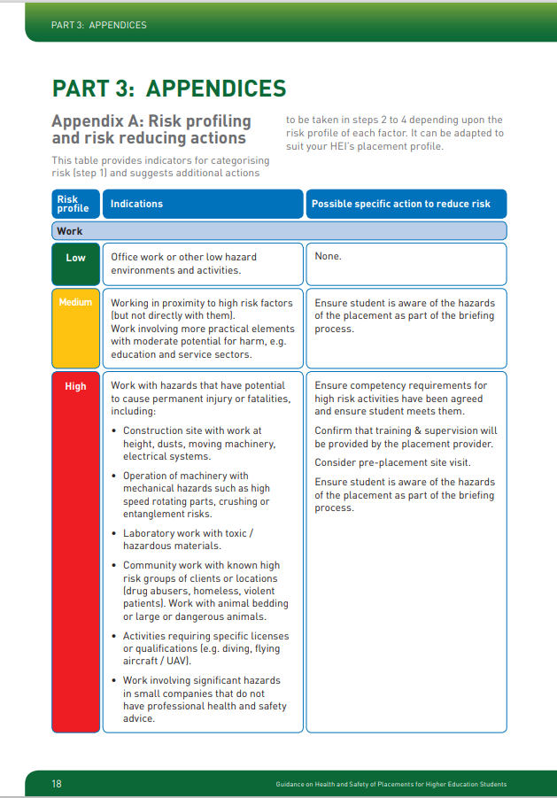

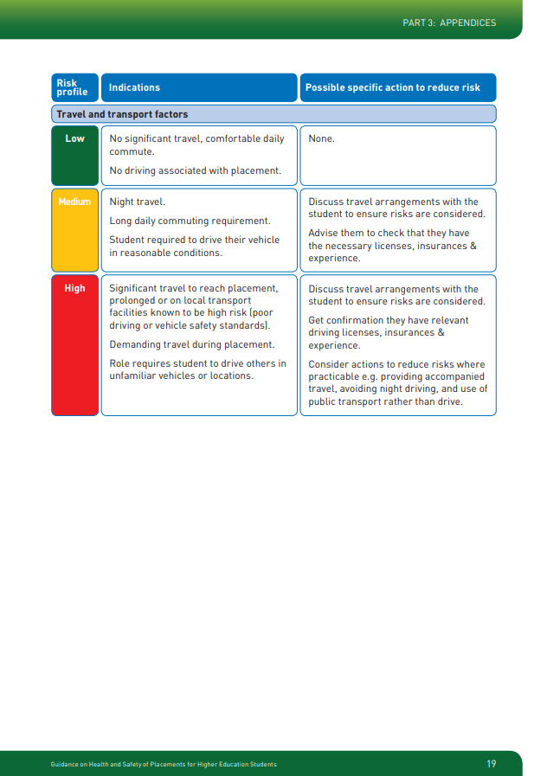

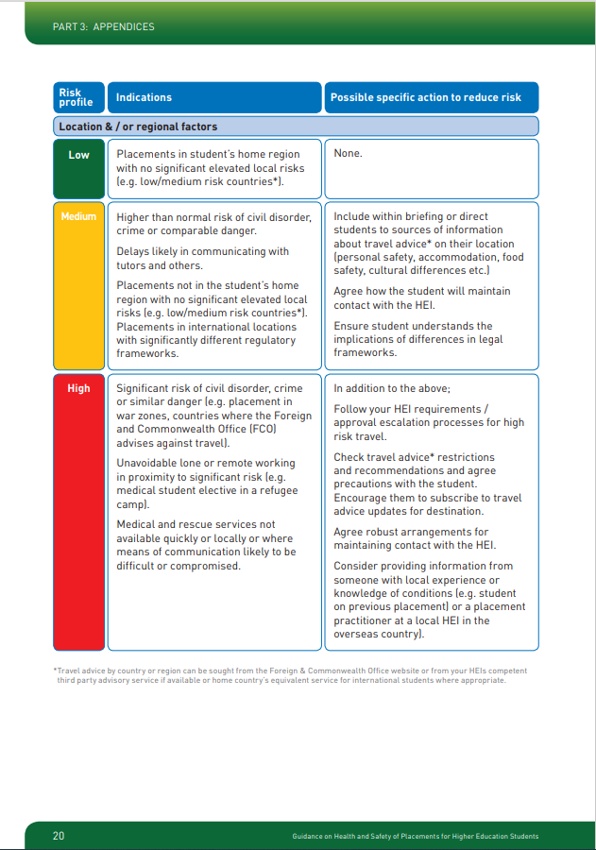

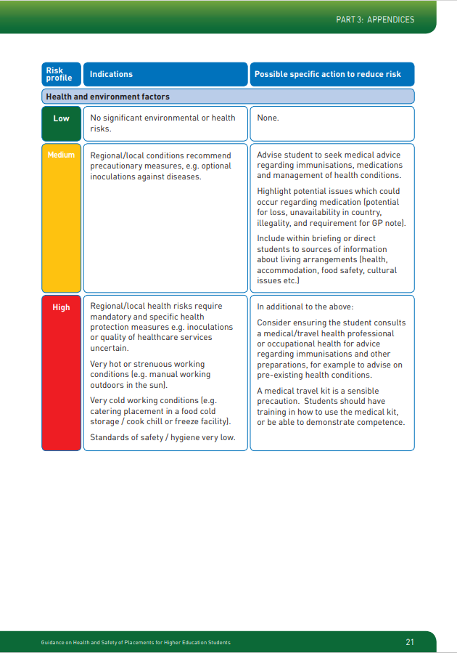

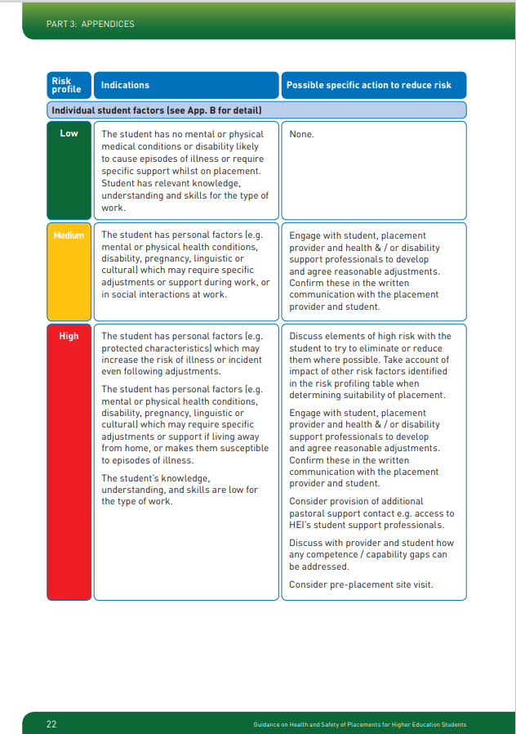

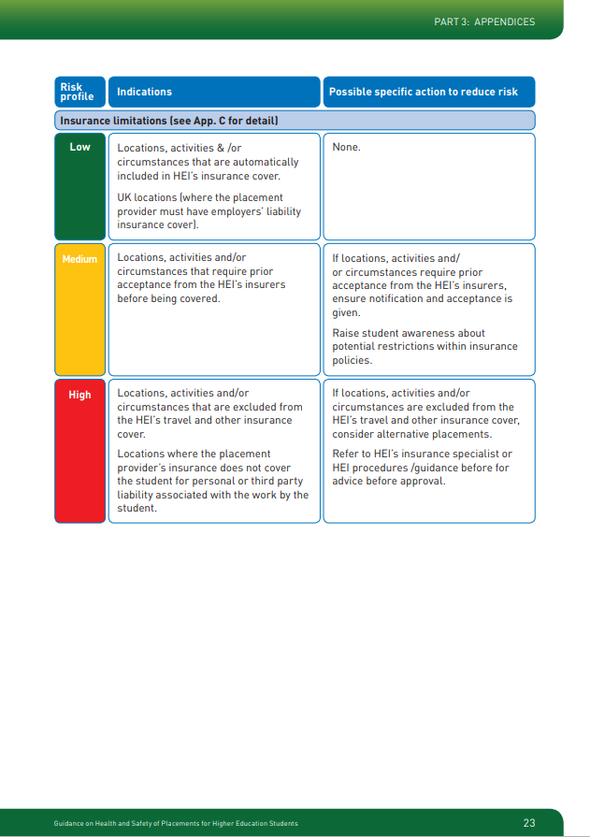

**RISK PROFILING**

|  |  |  |  |
| --- | --- | --- | --- |
| **School / Centre:** School of Electronics, Electrical Engineering and Computer Sciences | | | |
| **Placement Provider:**  PWC, Belfast Office | **Brief description of role:**  Office-based computer programming work | **Student(s):** | **Placement duration:** |

|  |  |  |  |
| --- | --- | --- | --- |
| **Factors** | **Risk Profile** | **Indications** | **Risk reduction actions** |
| Work factors | Low | Office work, low hazard activities | None |
| Travel and Transport | Low | No significant travel, comfortable daily commute | None |
| Location / Regional factors | Low | Student’s home region | None |
| Health and Environmental factors | Low | No significant environmental or health risks | None |
| Individual Student factors | Medium | Student has personal factors which may require adjustments | Engage with student Placement Provider and disability support team to agree reasonable adjustments. |
| Insurance limitations | Low | Placement Provider has Employer’s Liability Insurance Cover | None |

**RISK PROFILING**

|  |  |  |  |
| --- | --- | --- | --- |
| **School / Centre:** School of Biological Sciences | | | |
| **Placement-Provider:**  HP Farm, Johannesburg | **Brief description of role:**  Farm based role specialising in horse breeding. | **Student(s):** | **Placement duration:** |

| **Factors** | **Risk Profile** | **Indications** | **Risk reduction actions** |
| --- | --- | --- | --- |
| Work factors | Medium | Working in proximity to high risk factors. Work involving more practical elements with moderate potential for harm. | Confirm that training and supervision will be provided by the Placement Provider. Ensure student is aware of the hazards of the placement as part of the briefing process. Further risk control information requested from Placement Provider. |
| Travel and Transport | High | Role requires student to drive others in unfamiliar vehicles or locations and to operate farm machinery. | Discuss requirements with the student to ensure risks are considered. Get confirmation they have relevant driving licenses, insurances and experience. Consider actions to reduce risks where practicable e.g., avoiding night driving. Ensure vehicle insurance is provided by Placement Provider. Ensure training in use of farm machinery. |
| Location / Regional factors | High | Significant risk of civil disorder, crime or similar danger. Remote working in proximity to significant risk. | Check travel advice restrictions and recommendations and agree precautions with the student. Agree robust arrangements for maintaining contact with School. Obtain detailed information from someone with local experience or knowledge of conditions and of suitable controls, e.g., security around farm.  Follow approval escalation processes for high-risk travel. |
| Health and Environmental factors | Medium | Regional/local conditions recommend precautionary measures, e.g., optional inoculations against diseases. | Advise student to seek medical advice regarding immunisations, medications and management of health conditions. Highlight potential issues which could occur regarding medication (potential for loss, unavailability in country). |
| Individual Student factors | High | The student’s knowledge, understanding, and skills are low for the type of work. No experience working with horses. | Discuss with provider and student how any competence / capability gaps can be addressed. Information on training and supervision from Placement-Provider to take account of inexperience. |
| Insurance limitations | Low | Activities that are excluded from the University travel and other insurance cover. Cover does not include driving vehicles. | Refer to University insurance before for advice before approval. University Finance to be requested to increase insurance arrangements to include driving farm vehicles. |

NB: Further information on risks rated as High required. School escalated approval process required.

|  |  |  |  |  |  |
| --- | --- | --- | --- | --- | --- |
|  | **Low indications \*** | **Medium indications** | **Possible actions** | **High indications** | **Possible actions** |
| Work factors | Office work, low hazard activities | Working in proximity to high risk factors  Work involving more practical elements with potential for harm | Make student aware of hazards as part of briefing process | Work with hazards that have potential to cause permanent injury or fatalities | Ensure competence requirements have been agreed; Confirm training and supervision will be provided |
| Travel and Transport | No significant travel, comfortable daily commute | Night travel  Long daily commuting requirement  Student required to drive their vehicle | Discuss travel arrangements with student and advise them to check they have necessary insurances etc | Significant travel to placement on transport facilities known to be high-risk. | Confirmation of relevant licenses, insurances and experience.  Consider actions to reduce risks |
| Location / Regional factors | Student’s home region | Higher than normal risk of civil disorder, crime or comparable danger | Include within briefing sources of information about travel advice on their location | Significant risk of civil disorder, crime or similar danger  Unavoidable lone or remote working in proximity to risk | Follow your HEI requirements/ approval escalation processes for high-risk travel. |
| Health and Environmental factors | No significant environmental or health risks | Local conditions recommend precautionary measures | Advise student to seek medical advice regarding immunisations etc. | Local health risks require mandatory protection measures.  Very hot/strenuous conditions | Student consults a medical health professional for advice.  Medical travel kit is a sensible precaution |
| Individual Student factors (assessed by student and passed to PP/ Employer if necessary) | No personal factors likely to require support | Personal factors which may require specific adjustments | Engage with student, Placement-Provider and support to develop adjustments | Personal factors which may increase risk of illness or incident | Discuss elements of high risk with student to reduce them where possible |
| Insurance limitations | Placement-Provider has Employer’s Liability Insurance Cover | Activities or locations that required HEI approval | That approval is sought and gained | Activities and locations that aren’t covered by HEI insurance | Referral to specialists. |

**Risk Profile: School/ Education setting**

|  |  |  |  |
| --- | --- | --- | --- |
| School / Centre: Psychology Sector example: Education | | | |
| Placement-Provider: | Brief description of role:  Working one-to-one with children in a classroom | Student (s) | Placement duration: |

|  |  |  |  |
| --- | --- | --- | --- |
| **Factors** | **Risk Profile** | **Indications** | **Risk reduction actions** |
| Work factors | Medium | Work involves practical elements such as supervising children during breaks etc. | Ensure student is aware of hazards as part of briefing process |
| Travel and Transport | Low | No significant travel, school at walking distance from student | None |
| Location / Regional factors | Low | Placement in student’s home region with no elevated local risks | None |
| Health and Environmental factors | Low | No significant environmental or health risks | None |
| Insurance limitations | Low | Placement-Provider has Employer’s Liability Insurance Cover | None |

NB: Further information on risks rated as High required. School escalated approval process required.

|  |  |  |  |
| --- | --- | --- | --- |
| Factor | Risk Profile | Indications | Risk reductions actions |
| Individual student factors |  |  |  |

**Risk Profile: Office setting**

|  |  |  |  |
| --- | --- | --- | --- |
| School / Centre: Psychology Sector example: Office environment | | | |
| Placement-Provider: | Brief description of role: | Student (s) | Placement duration: |

|  |  |  |  |
| --- | --- | --- | --- |
| **Factors** | **Risk Profile** | **Indications** | **Risk reduction actions** |
| Work factors | Low | Office work, low hazard activities | None |
| Travel and Transport | Medium | Long daily commuting requirement | Discuss travel arrangements with student |
| Location / Regional factors | Low | No significant elevated local risks | None |
| Health and Environmental factors | Low | No significant environmental or health risks | None |
| Insurance limitations | Low | Placement-Provider has Employer’s Liability Insurance Cover | None |

NB: Further information on risks rated as High required. School escalated approval process required.

|  |  |  |  |
| --- | --- | --- | --- |
| Factor | Risk Profile | Indications | Risk reductions actions |
| Individual student factors |  |  |  |

**Risk Profile: Care Home**

|  |  |  |  |
| --- | --- | --- | --- |
| School / Centre: Psychology Sector example: Care home | | | |
| Placement Provider: | Brief description of role: | Student (s) | Placement duration: |

|  |  |  |  |
| --- | --- | --- | --- |
| **Factors** | **Risk Profile** | **Indications** | **Risk reduction actions** |
| Work factors | Medium/High | Work involves practical elements with moderate potential for harm – moving and handling patients, managing difficult behaviour/aggression | Confirm that training and supervision will be provided.  Ensure student is aware of hazards |
| Travel and Transport | Low | No significant travel | None |
| Location / Regional factors | Low | No significant elevated local risks | None |
| Health and Environmental factors | Medium | Moving and handling patients, infections and diseases such as Covid-19 | Include within briefing sources of information.  Advise student to seek medical advice regarding immunisations etc. |
| Insurance limitations | Low | Placement Provider has Employer’s Liability Insurance Cover | None |

NB: Further information on risks rated as High required. School escalated approval process required.

|  |  |  |  |
| --- | --- | --- | --- |
| Factor | Risk Profile | Indications | Risk reductions actions |
| Individual student factors |  |  |  |